MARK BETTERIDGE
  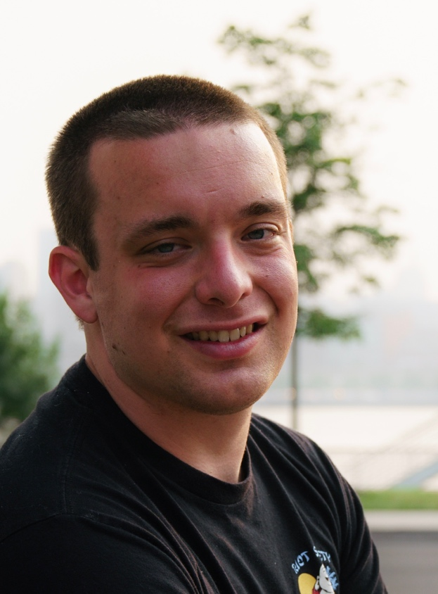 | Contact Details
   | Email: markbetteridge5@gmail.com
   | Phone: 856 287 3683
  Biography
  Eye Color: Blue
  Height: 5’5
  Hair Color: Brown
  Weight: 207 lbs
  Special Skills
  - Acting & puppetry
  - Stand-up comedy
  - Directing and producing
  - Clapper-loader (2nd AC)
  - Boom mic operation
  - Audio assistant
  - Video editing
Education | Projects
Associate of Arts (AA) in Liberal Arts & Sciences  Camden County College  Blackwood, NJ  December 2023  Instructors: Tom Murray, Drew Jacobs, James D. Patrick  Relevant Coursework  - Influence of Mass Media  - Film Appreciation  - Television Appreciation  - Filmmaking I  - Filmmaking II  Bachelor of Fine Arts (BFA) in Radio, Television, & Film  Rowan University  Glassboro, NJ  December 2025  Instructors: Patrick Ahearn, Jonathan Mason, Christopher Winkler, Gail Priest, Max Kimble, and others  Relevant Coursework  - Foundations of Media Production  - Screenwriting I: Writing the Short  - Digital Photography  - Video Art  - Workshop in Art: Puppetry  - Television Production  - Advanced Film Production  - Episodic Screenwriting I  - Experiencing Acting  Relevant Experience:  Independent Content Studio (2024-present)  - Experienced in on-camera and behind the scenes work; namely puppetry, audio assistant, boom operator, and production assistant  - Team participation in various projects such as commercials, podcasts, short skits, and more. | Selfie  Senior Year, Triton Regional High School, 2014 (dir. Kathy McCollaum)  - Played the role of Sam in a small, one-act dramedy production for a community audience  - Collaborated with 7 diverse cast members to bring the play to life, showcasing strong teamwork and communication skills  - Received positive feedback from instructor for delivering humorous and authentic performance  Rotten Pumpkins, Fall 2022 Semester (dir. Polina Yakymets)  - Played the role of Pumpkin #2, a mysterious, silent character who haunts the main protagonist in a bone-chilling manner.  Apparition, Spring 2023 Semester (dir. Mark Betteridge)  - Served as writer, director, and a puppeteer for a short horror-comedy film. Portrayed the short’s main antagonist, Sicko the Clown, a seemingly invisible spectre who torments the protagonist.  - Received positive feedback from my Filmmaking II instructor in regards to my unique portrayal and semi-professional puppetry skills.  Eyes in the Sky, Spring 2024 Semester (dir. Mark Betteridge)  - Directed, wrote, and edited a short film in which a mother and daughter combo are confronted by a mysterious walking cat balloon  - Received positive acclaim from my instructor for the cute, unique idea- as well as commendation for my directorial and editing skills.  Different Ways to Annoy, Spring 2024 (dir. Mark Betteridge)  - Directed, wrote, performed in, edited, and operated the camera for a student project- a comedic short that demonstrates various ways in which one can become annoyed.  - Demonstrated diverse acting abilities by portraying a human character and a puppet character in the same short,  The Independent Content Show, Episode 2, 2024 (dir. Michael P. Lucas)  - Performed the puppetry for “Chris P. Bacon” as an interview guest alongside world barbecue champion Ercole Chilla  Nipplegate: A Newsroom Scandal, 2025 (dir. Michael P. Lucas)  - Onscreen acting role as “The Bear” that wreaks havoc upon a South Jersey newsroom.  - Took on behind the scenes responsibilities as a boom mic operator and audio assistant.  The Devil Wears Spurs, 2025: (dir. Gage Smith)  - Served as an associate producer for a short Western Musical film entered into the 2025 48-Hour Film Festival.  Pony, 2026 (dir. Robert Hawk)  - Performed on camera as an extra.  Collisions, 2026 (dir. Adam Reim)  - Worked as 2nd AC (assistant camera)  - Responsible for transferring footage to the DIT, as well as writing out camera reports for editor; as well as slating before every scene.

